Jahangirnagar University
Institute of Information Technology
Savar, Dhaka-1342


Lab Report - 12
Configuring SPAN (Switch Port Analyzer) Port Mirroring in Cisco Packet Tracer
Course: Computer Networks Lab
Course Code: ICT-3104

Submitted To
Jesmin Akhter, PhD
Professor, Institute of Information Technology

Submitted By
Name: Md. Shaon Khan
ID: 1984
Batch: 52
Session: 2022-2023

Date of Submission
20 July 2026

Lab Report
Configuring SPAN (Switch Port Analyzer) Port Mirroring in Cisco Packet Tracer
1. Objective
The purpose of this lab is to set up and check Switch Port Analyzer (SPAN) port mirroring on a Cisco switch using Cisco Packet Tracer. SPAN lets a network administrator copy traffic from a chosen source port and send it to a destination port. This makes it possible to monitor and study network traffic without affecting the normal flow of data. In this lab, we will:
- Build a small network with a PC, a server, a switch, and a sniffer device.
- Set up a SPAN session that mirrors traffic from the server's switch port to the sniffer's port.
- Generate ICMP (ping) traffic between the PC and the server.
- Check the sniffer to confirm that the mirrored traffic is visible, which proves that SPAN is working correctly.
2. Setup / Requirements
The devices and software listed below were used to build the lab topology in Cisco Packet Tracer:
Device | Description
Server0 (Server-PT) | IP Address: 10.1.1.200, connected to switch port Fa0/1
Laptop0 (Laptop-PT) | IP Address: 10.1.1.100, connected to switch port Fa0/2
Switch0 (2960-24TT) | Layer 2 switch used to configure the SPAN session
Sniffer0 | Connected to switch port Fa0/3 to capture mirrored traffic
Software | Cisco Packet Tracer

Connections:
- Server0 (Fa0) connects to Switch0 Fa0/1
- Laptop0 (Fa0) connects to Switch0 Fa0/2
- Sniffer0 (Eth0) connects to Switch0 Fa0/3

3. Network Diagram
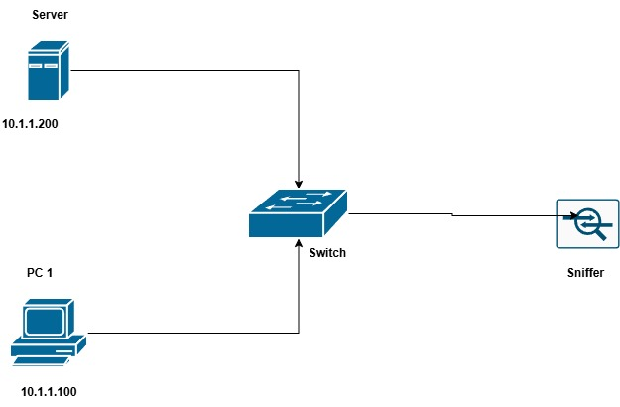
Figure 1: Logical network diagram - Server, PC, Switch, and Sniffer
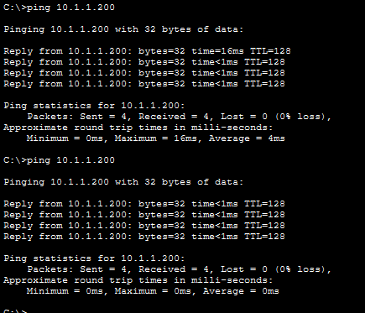
Figure 2: Actual topology built in Cisco Packet Tracer

4. Switch Configuration
The following commands were entered on Switch0 to create a local SPAN session. The server's port (Fa0/1) was used as the source, and the sniffer's port (Fa0/3) was used as the destination:
Switch>enable
Switch#configure terminal
Enter configuration commands, one per line. End with CNTL/Z.
Switch(config)#monitor session 1 source interface fastEthernet0/1
Switch(config)#monitor session 1 destination interface fastEthernet0/3
Switch(config)#end
Switch#show monitor session 1

Command breakdown:
- monitor session 1 source interface fastEthernet0/1 - sets Fa0/1 (server side) as the source port, so both incoming and outgoing traffic on this port are copied.
- monitor session 1 destination interface fastEthernet0/3 - sets Fa0/3 (sniffer side) as the destination port where the mirrored traffic is sent.
- show monitor session 1 - checks and confirms the SPAN session settings.
5. Output
a) Verification of SPAN Session
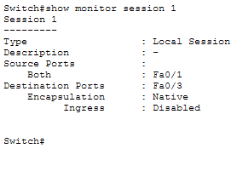
Figure 3: Output of 'show monitor session 1' confirming Fa0/1 as source and Fa0/3 as destination

b) Ping Test between PC and Server
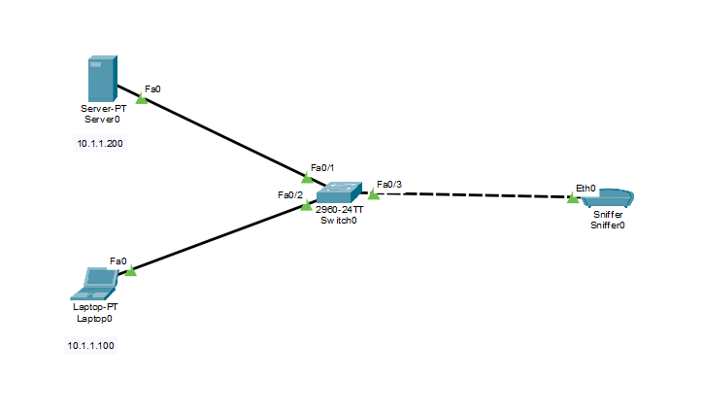
Figure 4: Successful ping from 10.1.1.100 to 10.1.1.200 with 0% packet loss
c) Sniffer Capture
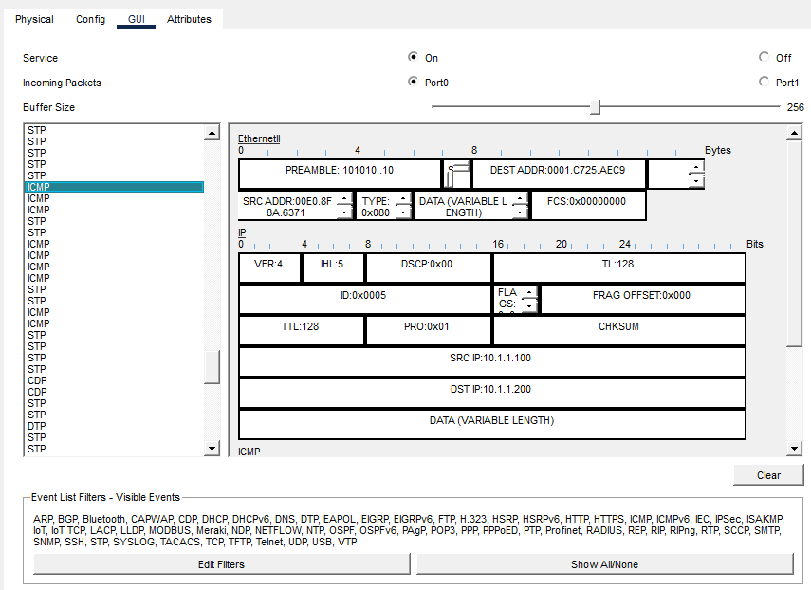
Figure 5: Sniffer GUI showing a captured ICMP packet with SRC IP 10.1.1.100 and DST IP 10.1.1.200
6. Result
The SPAN session was set up and tested successfully. The switch mirrored traffic from Fa0/1 (server port) to Fa0/3 (sniffer port). When ICMP echo requests and replies were sent between the Laptop (10.1.1.100) and the Server (10.1.1.200), the mirrored packets were captured and shown on the Sniffer device. This confirms that the SPAN configuration worked as expected.
7. Observation
- The ping test between the laptop and the server completed with 0% packet loss and round-trip times between 0 ms and 16 ms, which confirms basic Layer 3 connectivity.
- The 'show monitor session 1' command confirmed a Local SPAN session with Fa0/1 as the source (both directions) and Fa0/3 as the destination, using native encapsulation.
- The sniffer captured an ICMP packet showing source address 10.1.1.100 and destination address 10.1.1.200, which matches the ping traffic sent between the laptop and the server.
- Since SPAN mirrors both incoming and outgoing traffic by default, both the echo request and echo reply packets were visible on the sniffer.
- The sniffer port (Fa0/3) only received a copy of the traffic and did not interfere with the normal communication between the laptop and the server.
8. Conclusion
This lab showed how to configure and test SPAN (Switch Port Analyzer) port mirroring on a Cisco switch using Packet Tracer. By setting the server's port (Fa0/1) as the source and the sniffer's port (Fa0/3) as the destination, all traffic to and from the server was copied and made available for inspection without affecting normal network operation. The successful capture of ICMP packets on the sniffer shows that SPAN is a useful tool for network monitoring, traffic analysis, and troubleshooting. It is commonly used by network engineers to gain visibility into network traffic for security monitoring and diagnostics.

